Proof of Work

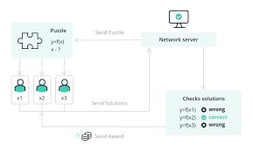

Miners need to solve cryptographic puzzle and find a valid hash of a block to be added in a chain for which they have to produce computational power and in return they will get block reward +transaction fee of block…….

It solves competing chain problem…